Software Design Fundamentals - Data Flow
# Source: AI Source: Provided by: [Data Path: Persons Table -> ID Column: 1, Name_En Column: Motasem Essam] -> From: [ChatGPT] on [1/23/2026]
Data Flow in software design describes how information moves through the system—from input to processing, storage, and output. It ensures that data reaches the right components efficiently and reliably.
👉 Think of it like the plumbing in a building—water (data) flows from source to destination through proper channels.

🔑 Key Points
# Source: AI Source: Provided by: [Data Path: Persons Table -> ID Column: 1, Name_En Column: Motasem Essam] -> From: [ChatGPT] on [1/23/2026]
- Shows how data moves between components
- Helps identify dependencies and interactions
- Ensures data integrity and consistency
- Useful for both HLD (system-level) and LLD (method-level)
- Helps in error handling and validation

🧱 Examples of Data Flow
# Source: AI Source: Provided by: [Data Path: Persons Table -> ID Column: 1, Name_En Column: Motasem Essam] -> From: [ChatGPT] on [1/23/2026]
Scenario: User Registration in a Web App
- User Input → UserController receives form data
- Business Logic → UserService validates and processes the data
- Storage → UserRepository saves the user in the database
- Notification → EmailService sends a welcome email

❌ Bad Example (Confused Data Flow)
# Source: AI Source: Provided by: [Data Path: Persons Table -> ID Column: 1, Name_En Column: Motasem Essam] -> From: [ChatGPT] on [1/23/2026]
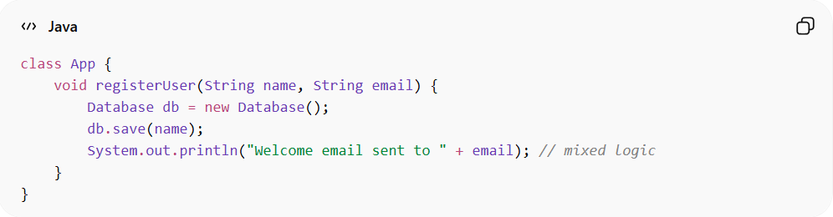
class App {
void registerUser(String name, String email) {
Database db = new Database();
db.save(name);
System.out.println("Welcome email sent to " + email); // mixed logic
}
}
👉 Problems:
- Data flow is unclear and mixed
- Business logic, storage, and notification all in one place
- Hard to test or change

✅ Good Example (Clear Data Flow)
# Source: AI Source: Provided by: [Data Path: Persons Table -> ID Column: 1, Name_En Column: Motasem Essam] -> From: [ChatGPT] on [1/23/2026]
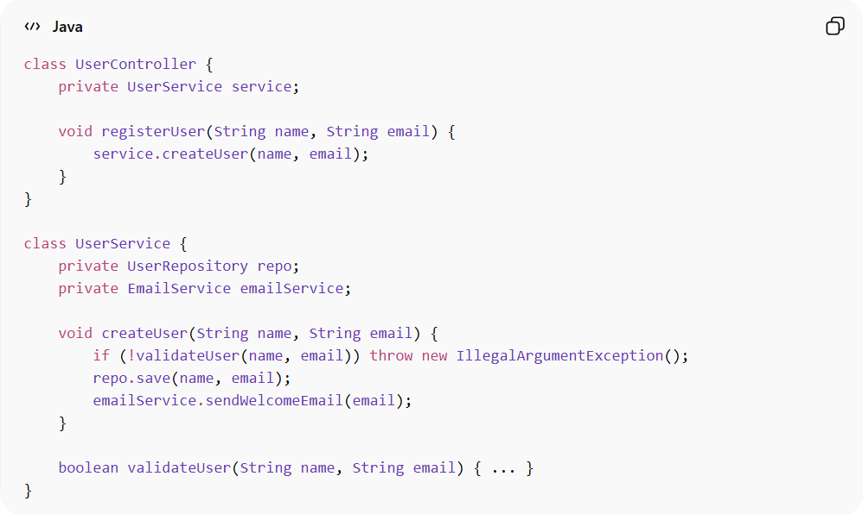
class UserController {
private UserService service;

void registerUser(String name, String email) {
service.createUser(name, email);
}
}

class UserService {
private UserRepository repo;
private EmailService emailService;

void createUser(String name, String email) {
if (!validateUser(name, email)) throw new IllegalArgumentException();
repo.save(name, email);
emailService.sendWelcomeEmail(email);
}

boolean validateUser(String name, String email) { ... }
}
Data Flow Diagram (Simplified)
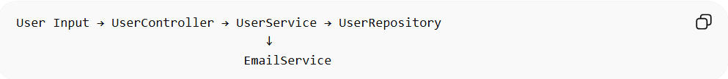
User Input → UserController → UserService → UserRepository
↓
EmailService

💡 Summary
# Source: AI Source: Provided by: [Data Path: Persons Table -> ID Column: 1, Name_En Column: Motasem Essam] -> From: [ChatGPT] on [1/23/2026]
Data Flow ensures that data moves logically and predictably through the system, connecting components without mixing responsibilities.

